**Outline of game concept**

I designed a 2D bullet hell boss fight for this coursework. I decided on this kind of game because I felt the short, story free nature of bullet hell fights would suit the project best due to the time constraints. I took inspiration from a specific boss fight in undertale when making my game, the Photoshop flowey fight, because that fight creates a feeling of panic in the player that I wanted to emulate. The goal of my game’s design is to make the player feel panicked and overwhelmed while they do everything they can to survive against a game doing everything it can to stop them. While making my game I kept this goal in mind and made everything work towards it. My game is structured in a main sequence where the player evades dozens of bullets aimed at them with random variance and 6 unique minigames that requires the player to think on their feet. The difficulty I designed my game with also contributes to its goal as I consciously made sure the player can’t survive if they stayed in one place the whole time.

**Discussion of game design**

The visual design of the game is very simplistic making use of only coloured squares and rectangles however I feel this simplistic style suits the nature of the game as you find yourself fighting against something people associate with a computer breaking. The music for my game was taken from the undertale soundtrack. As I made my game I intentionally fit my transitions to changes in the soundtrack in order to create a feeling of connection between the audio and visuals of my game. I have made use of some animation in the transition screen of my game in order to create a visual TV static effect that people associate with the sound in my soundtrack. The narrative of my game is minimal but it is based upon the fact that gamers see the blue screen of death as their ‘mortal enemy’ which allows me to quickly establish a reason for you to fight the boss of my game.

**Description of game mechanics**

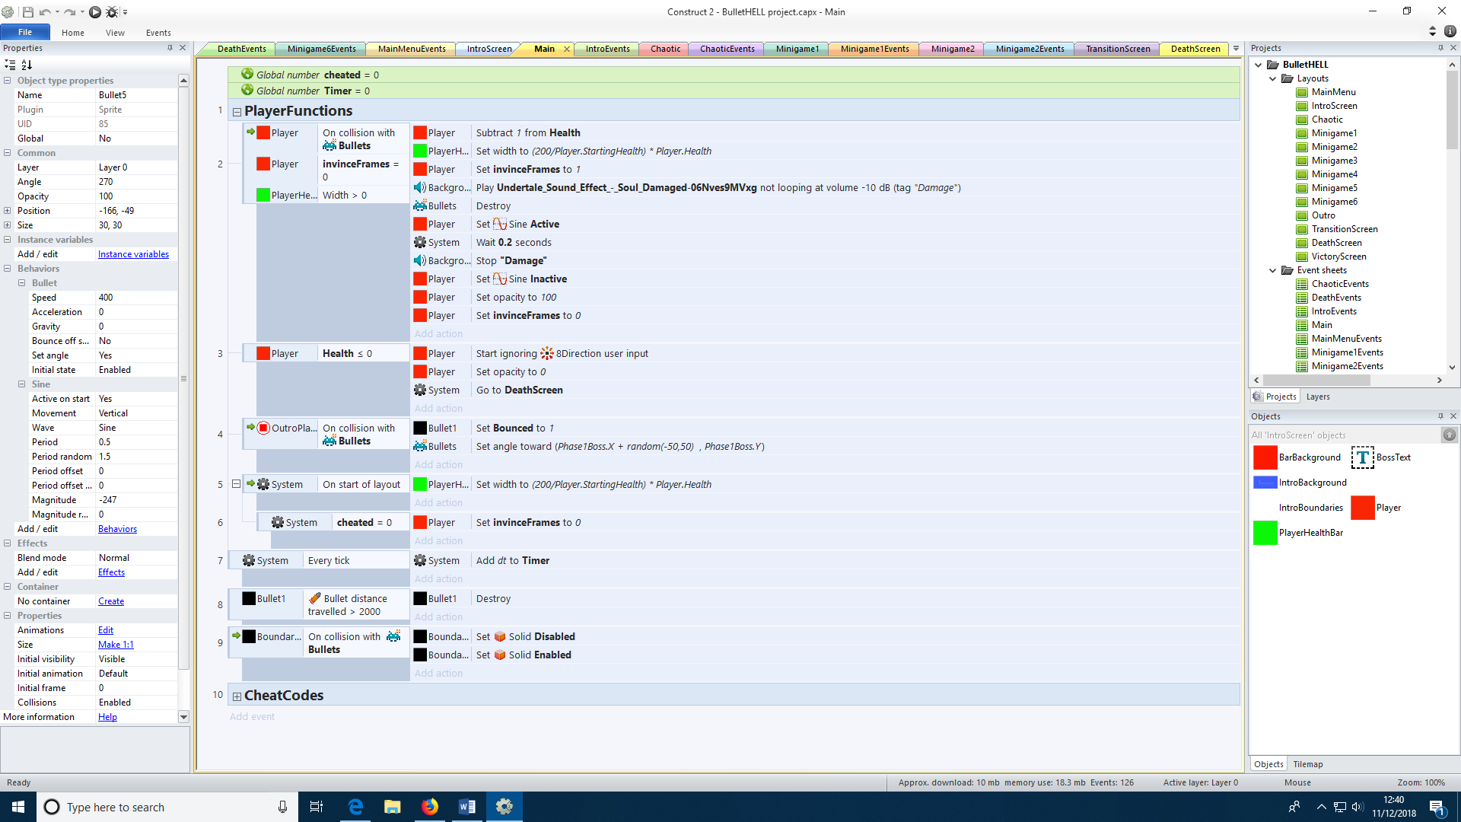My game consists of a main event sheet that’s used in almost every single other event sheet and one unique event sheet for every single layout. Most these event sheets are quite small due to the individual elements of my game being very simple. The player and bullets are controlled by built in behaviours while each gun acts differently depending on their purpose. The bullets use a simple bullet behaviour and are destroyed on contact with the player or if they travel a certain distance to reduce the load on the CPU. My game doesn’t have any severe technical issues however there are times when the framerate would drop slightly. This would make my music become out of synch with the timer in my game and the game itself. In order to fix this every frame I now add delta time to my timer in order to ensure the music and timer remain in synch.

I also made use of several instance variables to give my player frames of invincibility, check the time since the boss was last hit, track if a gun is already firing so that it isn’t chosen again and to track if a bullet has bounced off the outro player in order to tell if the boss should take damage.

**Explanation of the design of the user interface**

The player uses the basic 8 directional movement but with the acceleration and deceleration being effectively instant. This is because I found that if they aren’t then the game feels very clunky to play as other bullet hells don’t make use of acceleration. My main menu makes use of custom buttons rather than the built in buttons for construct as they weren’t as versatile as I needed. Instead I used sprites and text as buttons and used the on click action for the sprites in order to make them function. My main menu also has the instructions displayed as well as cheat codes that would be removed in a public release. I chose to make them yellow because I found that to be the best contrast with the background of the menu. While in the game the HUD is very minimal in that the player is only shown a health bar and not any number for their health. As the player is meant to be focused on surviving a bar is much more useful than a number for quickly assessing their situation.

**Justification for the use of advanced features**

Physics were only used at one time in my game as my game isn’t made to emulate any reality so game physics are unnecessary. The instance of physics being used is the bounced behaviour in the second minigame. I used the bounce behaviour to make guns move in unusual paths around the box while firing bullets at the player. This provides a unique challenge for the player as they have to try to keep distance between them and the guns to make dodging easier.

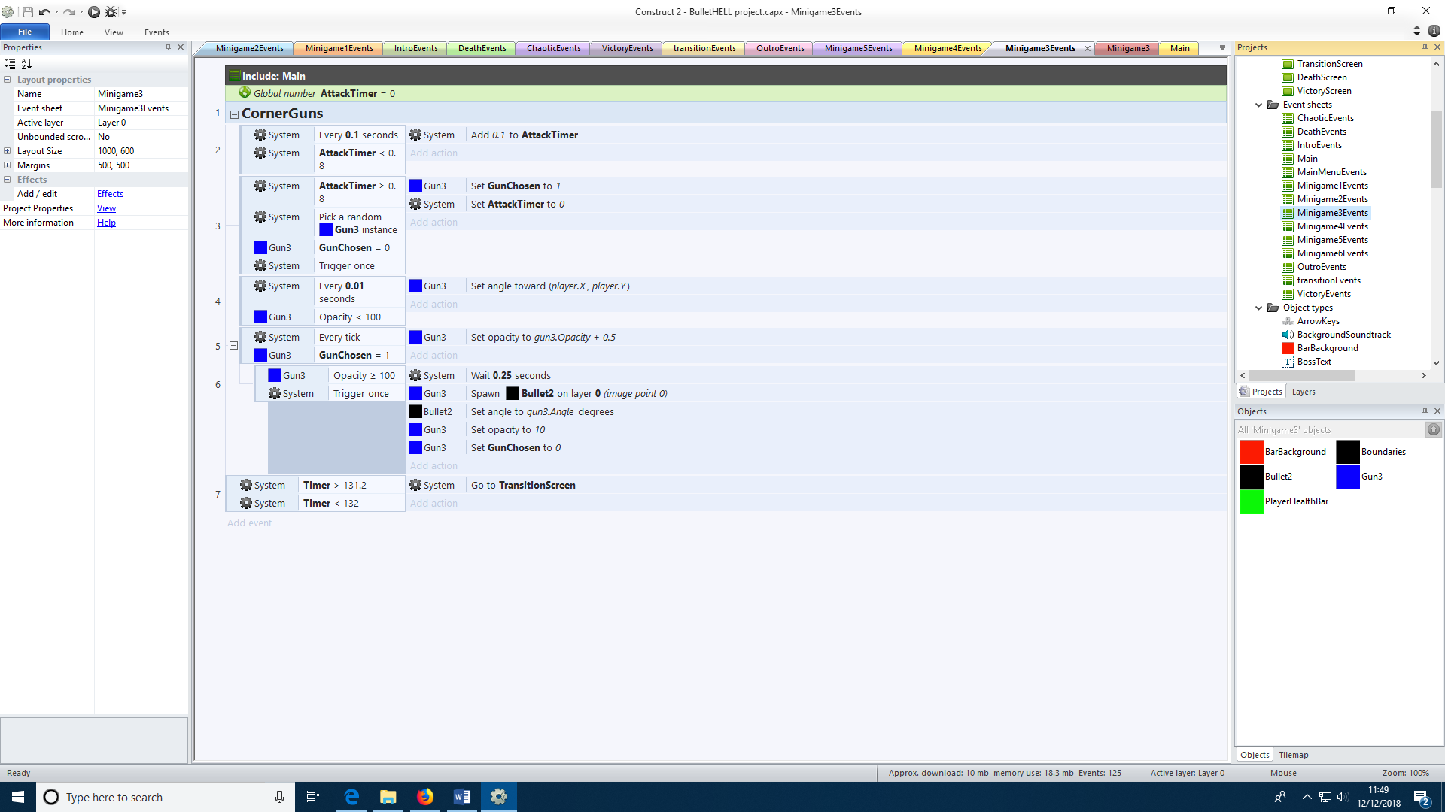

I did make use of the trigger once while true condition in the third minigame. Here I used it to ensure that each gun only fires once after charging then returns to its regular state. This was necessary because without this condition the guns would shoot many times before returning to their regular state.

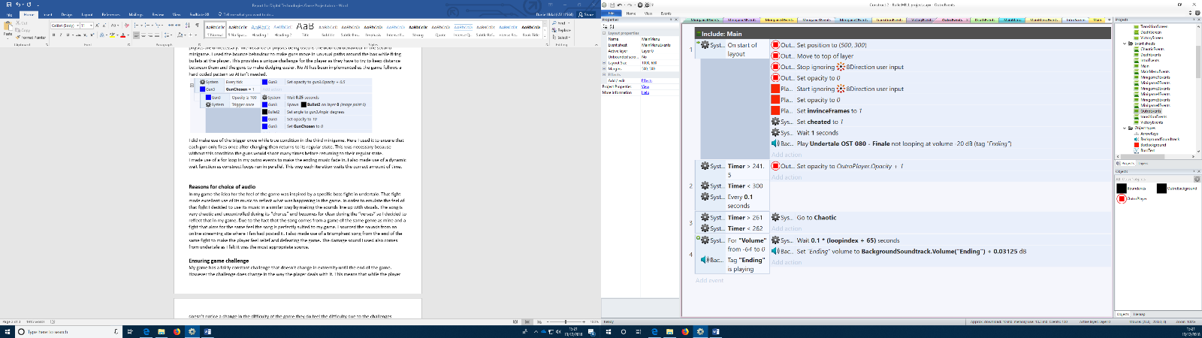I made use of a for loop in my outro events to make the ending music fade in. I also made use of a dynamic wait function as construct loops run in parallel. This way each iteration waits the correct amount of time.

**Reasons for choice of audio**

In my game the idea for the feel of the game was inspired by a specific boss fight in undertale. That fight made excellent use of its music to reflect what was happening in the game. In order to emulate the feel of that fight I decided to use its music in a similar way by making the sounds line up with visuals. The song is very chaotic and uncontrolled during its “chorus” and becomes for clear during the “verses” so I decided to reflect that in my game. Due to the fact that the song comes from a game of the same genre as mine and a fight that aims for the same feel the song is perfectly suited to my game. I sourced the sounds from an online streaming site where I fan had posted it. I also made use of a triumphant song from the end of the same fight to make the player feel relief and defeating the game. The damage sound I used also comes from undertale as I felt it was the most appropriate source.

**Ensuring game challenge**

My game has a fairly constant challenge that doesn’t change in extremity until the end of the game. However the challenge does change in the way the player deals with it. This means that while the player doesn’t notice a change in the difficulty of the game they do feel the difficulty due to the challenges changing in their approach. Part of the challenge of my game is attempting to keep yourself calm as when a player panics they tend to play worse. This adds another layer to my game as I have built a lot of it in order to try and induce panic in the player. My game has different difficulty levels however these only affect the amount of health the player has so the player doesn’t really notice the change despite the difficulty changing. The player is invested in the game by their instinctual need to survive. When the game suddenly throws the player into what they see as a life or death situation their survival instincts kick in and they don’t have time to think about the reality of the situation.

**Testing and evaluation**

Most functional testing was done by myself as I knew how the game was intended to function. I would make small changes to the event sheet and test each section of the game independently using the cheat codes I added to the game for development. This allowed me to test for bugs and mistakes in a vacuum for each minigame. Technical testing showed the framerate to not drop below ~55, except during the fade in at the outro where the framerate doesn’t matter, and an acceptably low 4%-8% CPU utilization. Playtesting was performed by a small number of fellow students who I asked to try the game and afterwards asked their opinion of the game. This resulted in some changes to the gameplay in order to improve enjoyment of the game such as increasing player interaction at the end of the game and adding a minimum period for bullets in the 6th minigame. It also resulted in dealing with exploits the players found like moving off the screen during the intro.

**Planning and organisation**

At the start of this coursework I spent roughly half an hour considering the type of game I wanted to make. After some thought I decided on a bullet hell boss fight. I felt I could realistically complete it in the time given. After making this choice I considered other bullet hell bosses and took inspiration from undertale’s Photoshop flowey fight. After, I spent another half hour noting down the timings of the music and found I needed 1 main chaotic sequence, 6 minigames and an intro sequence. I allocated 3 hours to complete each of these which comes to a total of 24 hours for the main sections of the game and 2 hours of research. I then planned time for the extra layouts I would need to flesh out my game which were the main menu, transition screen, victory and death screens, and the outro for the game. These were allocated 2 hours each coming to 35 hours total which was the total time given for the project. I felt the time I had given myself was more than sufficient and that I would have time to deal with any unexpected issues that might arise.

**Conclusion and critical reflection**

During this coursework I learned quite a bit about the process of making games with the iterative development cycle. I found it very useful to apply this cycle while making the game where I created part of the game tested it then evaluated the results of the test and made more changes. This allowed me to build up the game over time. My game is quite shallow in its content as I only had time to create 1 fight for the entire game. If I were to continue this game I would add more fights. I would also make the difference in difficulty more apparent. I might also add more to the graphics of the game to make it more visually interesting. Finally I would remove all the cheat codes I put into the game that I used while testing certain aspects of it. For the most part my game works perfectly as intended and the game is relatively fun to play so the limitation are in the design of the game.

**Music and sounds used in game**

Fox, TF, 2015, Your best nightmare [Song, Game music], Undertale game, available from: <https://www.youtube.com/watch?v=eUcThHVbrXY>

Fox, TF, 2015, Finale [Song, Game music], Undertale game, available from: <https://www.youtube.com/watch?v=yWjavxcGfqM>

Fox, TF, 2015, Damage [SFX, Game SFX], Undertale game, available from: https://www.youtube.com/watch?v=Dzwdr_RdFa0